Domas Brazdeikis

Aaron Smyth

Adam Plesca

Project proposal

Group 16

Contents

Explanation/Terminology 2

Overview 3

Target Audience 3

Game Design/Mechanics 4

Inspiration 7

Functionality 11

RoadMap 12

Summary 13

Explanation/Terminology

This section is dedicated to explaining some of the terms used in the document, for the purpose of explaining their meanings for those unfamiliar with them.

**Units:** Game Characters.

**Turn-based combat:** Units will take turns in acting, only one player can act at a time.

**Party:** Another word for team, commonly used in the gaming industry.

**Build/Building:** Refers to the sets up teams or characters via choice related game mechanics such as skill trees or equipment.

**Game Mechanics:** Game rules or features.

**Class/Classes:** Character related role with unique specialization. (e.g. Knight, Wizard, etc.)

**Stats:** Unit related attributes. (e.g. Health, Damage, etc.)

Overview

Our idea is to make a web-based game without the use of any engine tools such as Adobe Flash. This will be a turn-based combat game with a focus on party building. This game will incorporate various mechanics from several other games in order to get a unique flow of gameplay.

This project will aim to accomplish two things, provide a unique and challenging experience for players and to provide ease of access. Since the game will be web-based, everyone with a browser and a computer will have access to it, with a possibility of adding mobile support after the project is fully functional.

Target Audience

The target demographic for this project will mostly be gamers looking unique experience that is also easy to access. Due to the nature of web design, this game should be runnable on all computer machines and can be played at any time. Then game will be deployed on a server, but will also be open-source, free for anyone to download for themselves, run on their machines and modify the code.

Game Design/Mechanics

In order to provide users will a unique experience, we intend to add various mechanics to the game to keep players invested, here are some of mechanical features we intend to include:  
  
**Classes:** Playable characters will have a unique class, aimed toward specific playstyles with a variety of strengths and weaknesses.

**Skill Tree:** Each class will be given a set of skills that can be modified to provide additional effects or even redefine their playstyle. We currently have not decided on the scope (complexity) of these trees.

**Levelling:** Once a quest has been successfully completed, each party member will earn experience. When experience reaches a certain point, that member will earn a skill point, used to for interacting with their corresponding skill tree.

**Party System:** When embarking on a quest, players can choose up to four members to add to their party, allowing for a variety of team compositions.

**Attack Types:** There will be two types of attacks, physical and magical. Physical attacks utilise an energy system while magical attacks will have a cooldown system.

**Energy:** Physical attacks will have an energy cost. At the start of a unit’s turn, they regenerate a portion of energy. If a unit runs out of energy, it will be exhausted and unable to act for their next turn.

**Cooldown:** Magical spells use a cooldown system which determines how many turns they must wait until they can use the same spell again.

**Wind-Up Ability:** An attack or spell that is not performed immediately, but instead after a set number of turns. These abilities are far more powerful but allows players or enemies anticipate them and plan accordingly.

**Stagger:** Each enemy unit will have a stagger value. Performing attacks to that enemy will decrease their stagger value. If an attack was to bring the stagger value to zero or below, it would be considered a **staggering blow**, which would deal increased damage and prevent that unit from acting for the next turn. Staggering blows also cancel wind-up abilities. A portion of stagger is regenerated a start of the unit’s turn.

**Armour:** Reduces the amount of damage that units take from attacks. There is physical and magical armour, which reduces damage from corresponding types. Armour reduces damage as a percentage. Player units are limited to seventy percent damage reduction, for balancing reasons.

**Armour-Piercing attacks:** Some physical attacks can ignore a percentage of the unit’s armour.

**Armour-Shread:** A spell that reduces a percentage of unit’s armour for a set number of rounds.

**Turns and Rounds:** Each round, player units will only be able to act once, while some enemies will be able to act multiple times within each round. Once all units have acted, the round ends and unit turns are refreshed.

**Duel-System:** During combat, at the start of each round, a set of cards are drawn. These cards are used to determine action priority. There will be thirteen cards in total. The first twelve will be their numeric values, while the thirteenth one will be represented by a star and known as the **star card**.

At the start of each turn the player or the enemy will place a card, the order is determined by the round. On odd rounds, the player gets to place down the first card, on even rounds, the enemy places down their first card. Once a card has been placed, the opponent will then proceed to place their card in response. We will refer to the one who placed the first card as the **initiator** and the one who placed the second as the **challenger**.

If the challenger places a card with an equal or higher value than the initiator, the challenger will get to act with a unit, otherwise the initiator acts. This is referred to a **duel**. Once the player/enemy has finished their turn, another duel occurs to determine who will act next. The victor of the previous duel will then place their card first (unless a new round begins).

These duels will continue until one side has run out of turns, in which case the opposing side gets to use the rest of their turns before the round ends. Unlike the numbered cards, the star cards will guarantee a turn to whoever places it. If an initiator places it, they will get to act first, but the challenger still has place down one of their cards to finish the duel. A star card cannot block another star card but can block any other non-star card.

**Gear:** Each player unit can be equipped with a variety of gear. There are five possible rarities a piece of gear can be, Common, Uncommon, Rare, Epic and Legendary. Each rarity has a set number of stats.

Common will have only one stat, Uncommon will have two, Rare will have three, Epic will have four and Legendary will have four normal stats and one unique stat that is exclusive to its rarity. Gear can be obtained through completing quests.

Inspiration

[**Darkest Dungeon**](https://store.steampowered.com/app/262060/Darkest_Dungeon/)

A turn-based combat game with a grim setting. This game offers a variety of classes to choose from, each possessing their own unique abilities. It goes for a punishing approach to gameplay by adding a variety of randomness throughout the game mechanics, offering unpredictable encounters that are often times, out of the player’s control, forcing them to make the best out of bad situations.

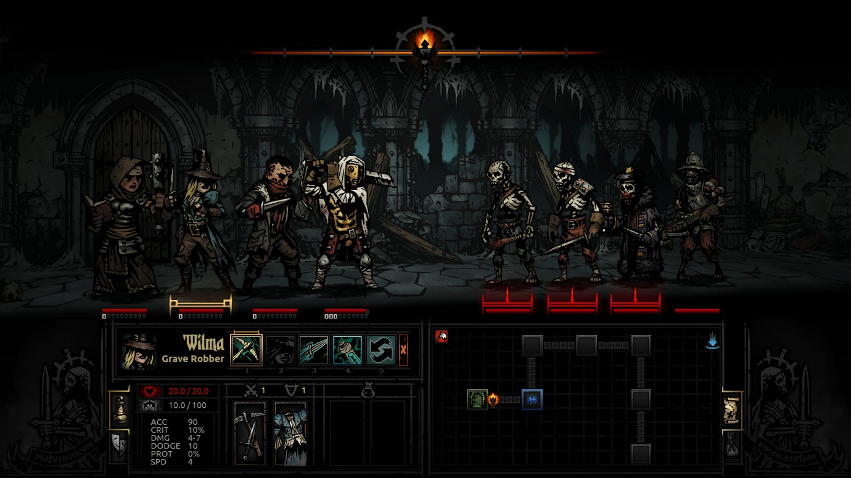

We want to include a similar class-based combat system but without the overwhelming element of randomness, as we want to let players control the battles by choosing accordingly.

In summary, here are some mechanics that we were inspired by in [Darkest Dungeon](https://store.steampowered.com/app/262060/Darkest_Dungeon/):

* Class system
* Party system
* [Trinket](https://darkestdungeon.fandom.com/wiki/Trinkets?so=search) system

[**Monster Sanctuary**](https://store.steampowered.com/app/814370/Monster_Sanctuary/)

Another turn-based combat game, inspired by [Pokémon](https://en.wikipedia.org/wiki/Pokémon). This game uses a monster system where each monster has their own skill tree. Because of this, it allows players to build each monster in a variety of different ways, which greatly expands party building.

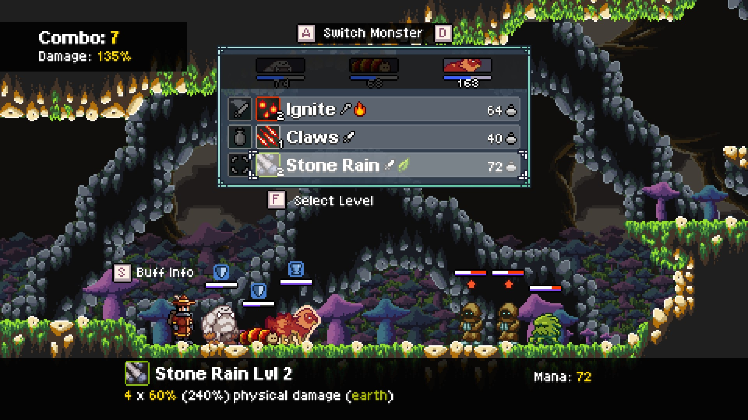

We took great inspiration from their skill tree system.

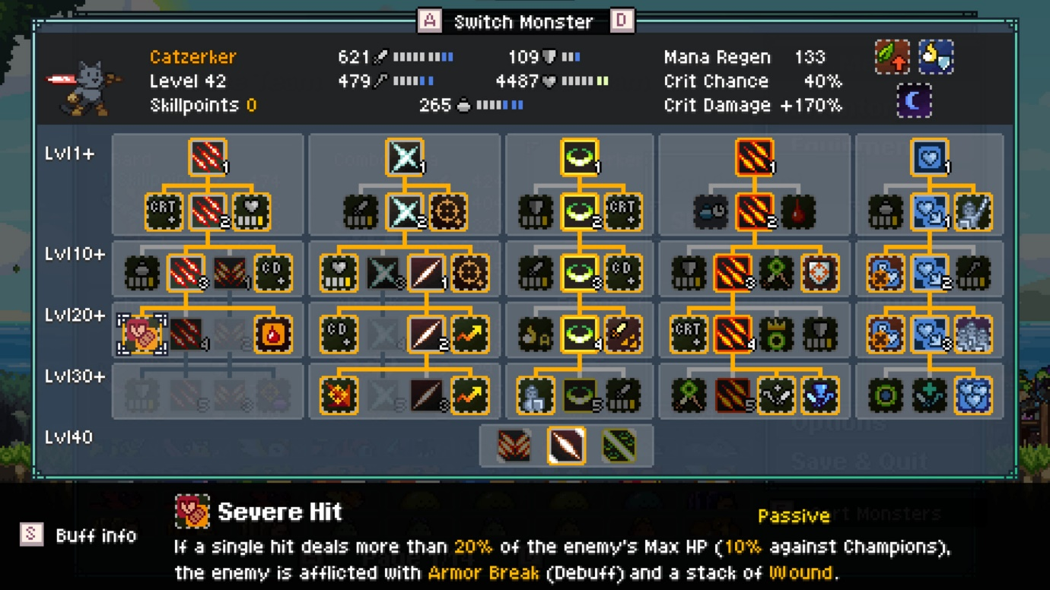

[**Honkai: Star Rail**](https://hsr.hoyoverse.com/en-us/)

Turn-based combat game, heavily focussed on party building. The features we took inspiration from this game are:

**Weakness-break system**: Each unit has an elemental weakness, attacking targets with corresponding element types will lower their weakness bar. Once the bar is completely depleted, the target’s turn will be delayed and suffer a negative effect based on the element.

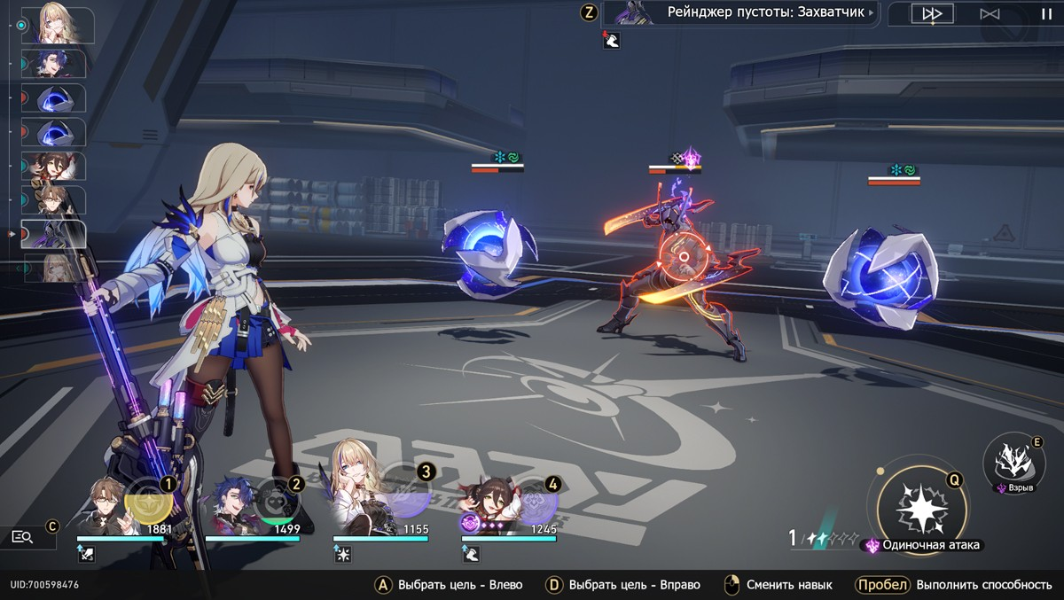

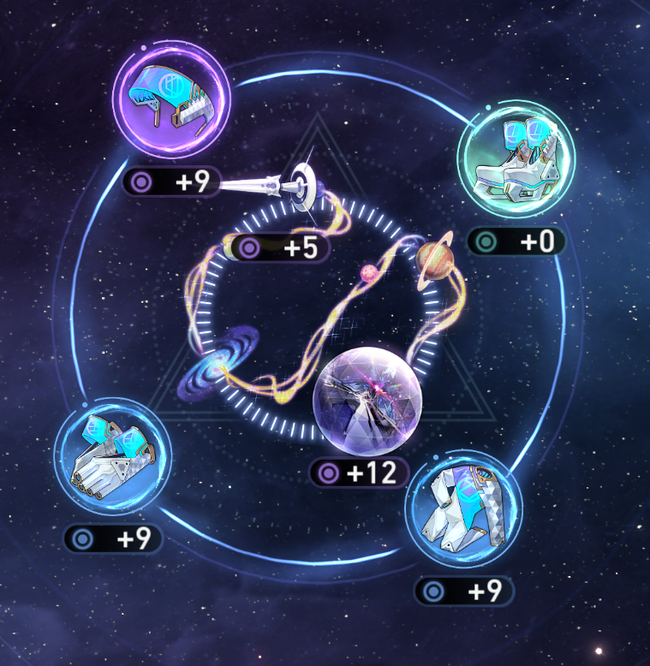**Relic system:** Item that can be equipped by playable characters to enhance their various stats.

These two features inspired us to make our own Stagger and Gear Systems.

**Dueling System**

We felt that most turn-based combat games have a fairly basic system when it comes to choosing turns. Most of these games either let players act first or leave it up to chance based on another value relating to each unit.

We wanted to expand on this system by adding an extra layer of strategy to determine turn order.

Functionality

Since this project will be web-based, most of the coding will be made using JavaScript and styling of the game will be made via CSS.

Extra image assets will be via an image editing application known as [Krita](https://krita.org/en/). This application acts as a free alternative to Photoshop.

We will incorporate a save system that allows users to save their progress so that they can continue to play the game after they close the page and keep all the progress they have made. This system will be made using JSON files to store player information.

Our game will be implemented using a CSS Grid to easily position objects. This grid features a total of 10,000 possible positions on the page while also offering us to layer objects/images on top of each other. This layout should also allow for reliable responsiveness on computer screens.

RoadMap

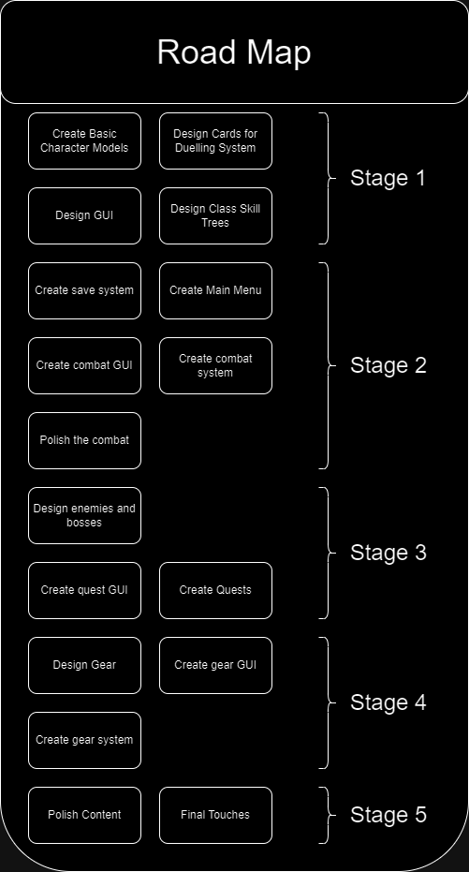Game developers often use Roadmaps in various styles to plan out stages of development.

This is the road map we will be using for this project. We decided not to include dates just yet prevent potential procrastination in our team. Additionally, it is hard to determine how long each stage will take and, in any case, we plan to complete this project as soon as possible.

Summary

This is a highly ambitious project, where we will attempt to make a fully functional turn-based combat game within a web page without game development software or tools. Its appeal will be from its various complex systems that encourage players to try out different strategies.